Bluetooth Protocol Stack

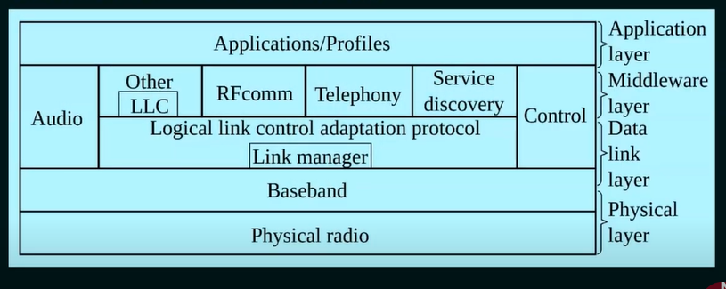

1. Physical Radio (RF) layer: It performs modulation/demodulation of the data into RF signals. It defines the physical characteristics of a bluetooth transceiver. If defines two types of physical link: connection-less and connection-oriented.
2. Baseband Link Layer: It performs the connection establishment within a piconet.
3. Link Manager protocol layer: It performs the management of the already established links. It also includes authentication and encryption processes.
4. Logical Link Control and Adaptation protocol layer: It is also known as the heart of the bluetooth protocol stack. It allows the communication between upper and lower layers of the bluetooth protocol stack. It packages the data packets received from upper layers into the form expected by lower layers. It also performs the segmentation and multiplexing.
5. RF comm Layer: It is short for radio frontend component. It provides a serial interface with WAP and OBEX.
6. TCS: It is short for Telephony Control Protocol. It provides telephony service.
7. Application layer: It enables the user to interact with the application.